DATA Structure
Assignment #5
F24-0767

TASK#1:
#include <iostream>
#include <stack>
using namespace std;

struct Node
{
int vertex;
Node *next;
Node(int v) : vertex(v), next(NULL) {}
};

class AdjacencyList
{
Node **arr;
int size;

public:
AdjacencyList(int s)
{
size = s;
arr = new Node *[size];
for (int i = 0; i < size; i++)
arr[i] = NULL;
}

void addEdge(int src, int des)
{
Node *newNode = new Node(des);
newNode->next = arr[src];
arr[src] = newNode;
}

Node **getArray()
{
return arr;
}

int getSize()
{
return size;
}

void display()
{
for (int i = 0; i < size; i++)
{
cout << i << " : ";
Node *temp = arr[i];
while (temp != NULL)
{
cout << temp->vertex << " -> ";
temp = temp->next;
}
cout << "NULL\n";
}
}
};

void dfs1(int v, bool visited[], stack<int> &st, Node **graph)
{
visited[v] = true;

Node *temp = graph[v];
while (temp != NULL)
{
if (!visited[temp->vertex])
dfs1(temp->vertex, visited, st, graph);

temp = temp->next;
}

st.push(v);
}

void dfs2(int v, bool visited[], Node **rev)
{
visited[v] = true;

Node *temp = rev[v];
while (temp != NULL)
{
if (!visited[temp->vertex])
dfs2(temp->vertex, visited, rev);

temp = temp->next;
}
}

// graph ko reverse karo
Node **buildReverseGraph(AdjacencyList &g)
{
int n = g.getSize();
Node **original = g.getArray();
Node **rev = new Node *[n];
for (int i = 0; i < n; i++)
rev[i] = NULL;

for (int u = 0; u < n; u++)
{
Node *temp = original[u];
while (temp != NULL)
{
Node *newNode = new Node(u);
newNode->next = rev[temp->vertex];
rev[temp->vertex] = newNode;

temp = temp->next;
}
}
return rev;
}

int kosaraju(AdjacencyList &g)
{
int n = g.getSize();
Node **graph = g.getArray();

bool *visited = new bool[n]();
stack<int> st;

// stack maa order add karo
for (int i = 0; i < n; i++)
if (!visited[i])
dfs1(i, visited, st, graph);

// reverse edges lo
Node **rev = buildReverseGraph(g);

for (int i = 0; i < n; i++)
visited[i] = false;

int scc = 0;

while (!st.empty())
{
int v = st.top();
st.pop();

if (!visited[v])
{
dfs2(v, visited, rev);
scc++;
}
}

return scc;
}

int main()
{
AdjacencyList adj(3);

adj.addEdge(0, 1);
adj.addEdge(0, 2);
adj.addEdge(2, 1);

cout << "Graph:\n";
adj.display();

cout << "\nNumber of Strongly Connected Components = " << kosaraju(adj) << endl;

return 0;
}

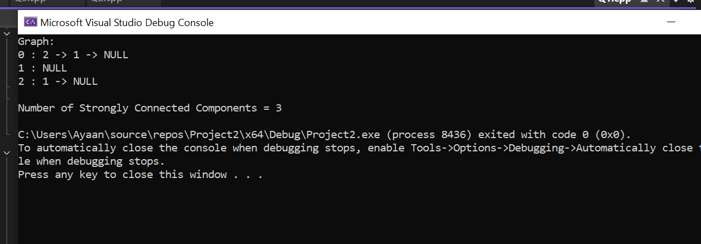

QUESTION#02:
include <iostream> include <string> using namespace std;

const int MAX_CITIES = 30; // Max number of cities

// ode structure struct Cityode
{
int cityId;
int weight; // Distance Cityode* nextfltr;
};

// Graph Class class CityGraph
{
private:
string cityames[MAX_CITIES]; // Stores names like "Gawadar" int cityCount;

// 1. Adjacency Matrix
int adjMatrix[MAX_CITIES][MAX_CITIES];

// 2. Adjacency List
Cityode* adjList[MAX_CITIES];

// For formatting
void printSpaces(int n);

public:
CityGraph();
int GetOrAddCity(string name);
void AddConnection(string city1, string city2, int dist); void ShowMatrix();
void ShowList();
};
// Graph Implementation CityGraph::CityGraph()
{
cityCount = 0;

// Initialize Matrix with 0
for (int i = 0; i < MAX_CITIES; i++)
{
adjList[i] = ULL; // Init List
for (int j = 0; j < MAX_CITIES; j++)
{
adjMatrix[i][j] = 0;
}
}
}

// To print spaces

void CityGraph::printSpaces(int n)
{
for (int i = 0; i < n; i++) cout << " ";
}

// To map String ame -> Integer ID
int CityGraph::GetOrAddCity(string name)
{
// Check if city exists
for (int i = 0; i < cityCount; i++)
{
if (cityames[i] == name) return i;
}

// If not, add it
if (cityCount < MAX_CITIES)
{
cityames[cityCount] = name; return cityCount++;
}
return -1; // Error: Too many cities
}

void CityGraph::AddConnection(string city1, string city2, int dist)
{
int u = GetOrAddCity(city1); int v = GetOrAddCity(city2);

if (u == -1 || v == -1) return;

// 1. flopulate Adjacency Matrix adjMatrix[u][v] = dist; adjMatrix[v][u] = dist;

// 2. flopulate Adjacency List
// Add v to u's list
Cityode* node1 = new Cityode; node1->cityId = v;
node1->weight = dist;
node1->nextfltr = adjList[u]; adjList[u] = node1;

// Add u to v's list (Undirected) Cityode* node2 = new Cityode; node2->cityId = u;
node2->weight = dist;
node2->nextfltr = adjList[v]; adjList[v] = node2;
}

void CityGraph::ShowMatrix()
{
cout << endl << "\t\t\t\t\t\t\t--- Adjacency Matrix Representation ---" << endl
<< endl;

// Column width for alignment

int colWidth = 6;
int nameColWidth = 16; // Increased to fit "Killa-Saifullah"

// flrint eader Row printSpaces(nameColWidth);
for (int i = 0; i < cityCount; i++)
{
// flrint first 3 chars of city name for column headers cout << cityames[i].substr(0, 3);

// fladding after header name int padding = colWidth - 3; printSpaces(padding);
}
cout << endl;

// flrint Rows
for (int i = 0; i < cityCount; i++)
{
// flrint Row ame cout << cityames[i];

// Dynamic padding for Row ame
int nameLen = cityames[i].length();
int namefladding = nameColWidth - nameLen;
if (namefladding > 0) printSpaces(namefladding);

for (int j = 0; j < cityCount; j++)
{
cout << adjMatrix[i][j];

// Dynamic padding for matrix values int valLen = 0;
if (adjMatrix[i][j] == 0) valLen = 1;
else if (adjMatrix[i][j] < 10) valLen = 1; else if (adjMatrix[i][j] < 100) valLen = 2; else valLen = 3;

int valfladding = colWidth - valLen; printSpaces(valfladding);
}
cout << endl;
}
}

void CityGraph::ShowList()
{
cout << endl << "\t\t\t\t\t\t\t--- Adjacency List Representation ---" << endl;

for (int i = 0; i < cityCount; i++)
{
cout << cityames[i] << " -> "; Cityode* curr = adjList[i]; while (curr != ULL)
{
cout << "(" << cityames[curr->cityId] << ", " << curr->weight << "km)
";
curr = curr->nextfltr;

}
cout << endl;
}
}

// MAI flROGRAM int main()
{
CityGraph balochistanMap;

cout << "Building Graph from Table." << endl;

// Data from Table: balochistanMap.AddConnection("Gawadar", "Turbat", 166);
balochistanMap.AddConnection("Gawadar", "Bela", 605);
balochistanMap.AddConnection("Bela", "Khuzdar", 222);
balochistanMap.AddConnection("Turbat", "Khuzdar", 474);
balochistanMap.AddConnection("Khuzdar", "Kalat", 159);
balochistanMap.AddConnection("Bolan", "Sibi", 68);
balochistanMap.AddConnection("Sibi", "Mach", 96);
balochistanMap.AddConnection("Mach", "Killa-Abdullah", 152); balochistanMap.AddConnection("ushki", "Killa-Abdullah", 210); balochistanMap.AddConnection("Mach", "Killa-Saifullah", 235);
balochistanMap.AddConnection("Killa-Saifullah", "Zob", 144); balochistanMap.AddConnection("Khuzdar", "Jhal Magsi", 145); balochistanMap.AddConnection("Jhal Magsi", "Jafarabad", 85); balochistanMap.AddConnection("Jhal Magsi", "Bolan", 136); balochistanMap.AddConnection("Bolan", "Dera Bugti", 140); balochistanMap.AddConnection("Dera Bugti", "Barkan", 104); balochistanMap.AddConnection("Barkan", "Kohlu", 30); balochistanMap.AddConnection("Sibi", "arnai", 77); balochistanMap.AddConnection("arnai", "Ziarat", 110); balochistanMap.AddConnection("Ziarat", "flishni", 101);
balochistanMap.AddConnection("flishni", "Killa-Abdullah", 43);
balochistanMap.AddConnection("Turbat", "Washuk", 346);
balochistanMap.AddConnection("Washuk", "Kharan", 161); balochistanMap.AddConnection("Kharan", "ushki", 129); balochistanMap.AddConnection("Kharan", "Chagai", 159);
balochistanMap.AddConnection("flishni", "Killa-Saifullah", 142);

// Display Outputs balochistanMap.ShowList(); balochistanMap.ShowMatrix();

cout << endl; system("pause"); return 0;
}

OUTPUT:

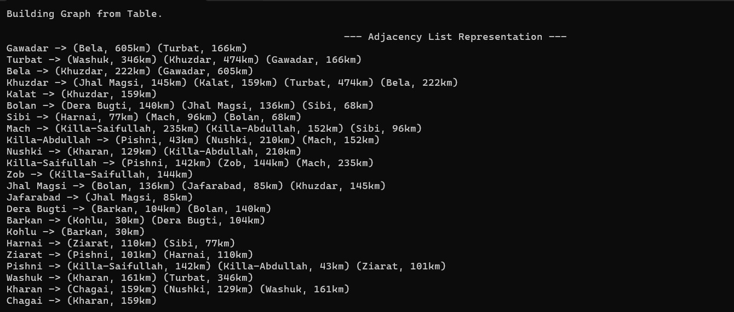
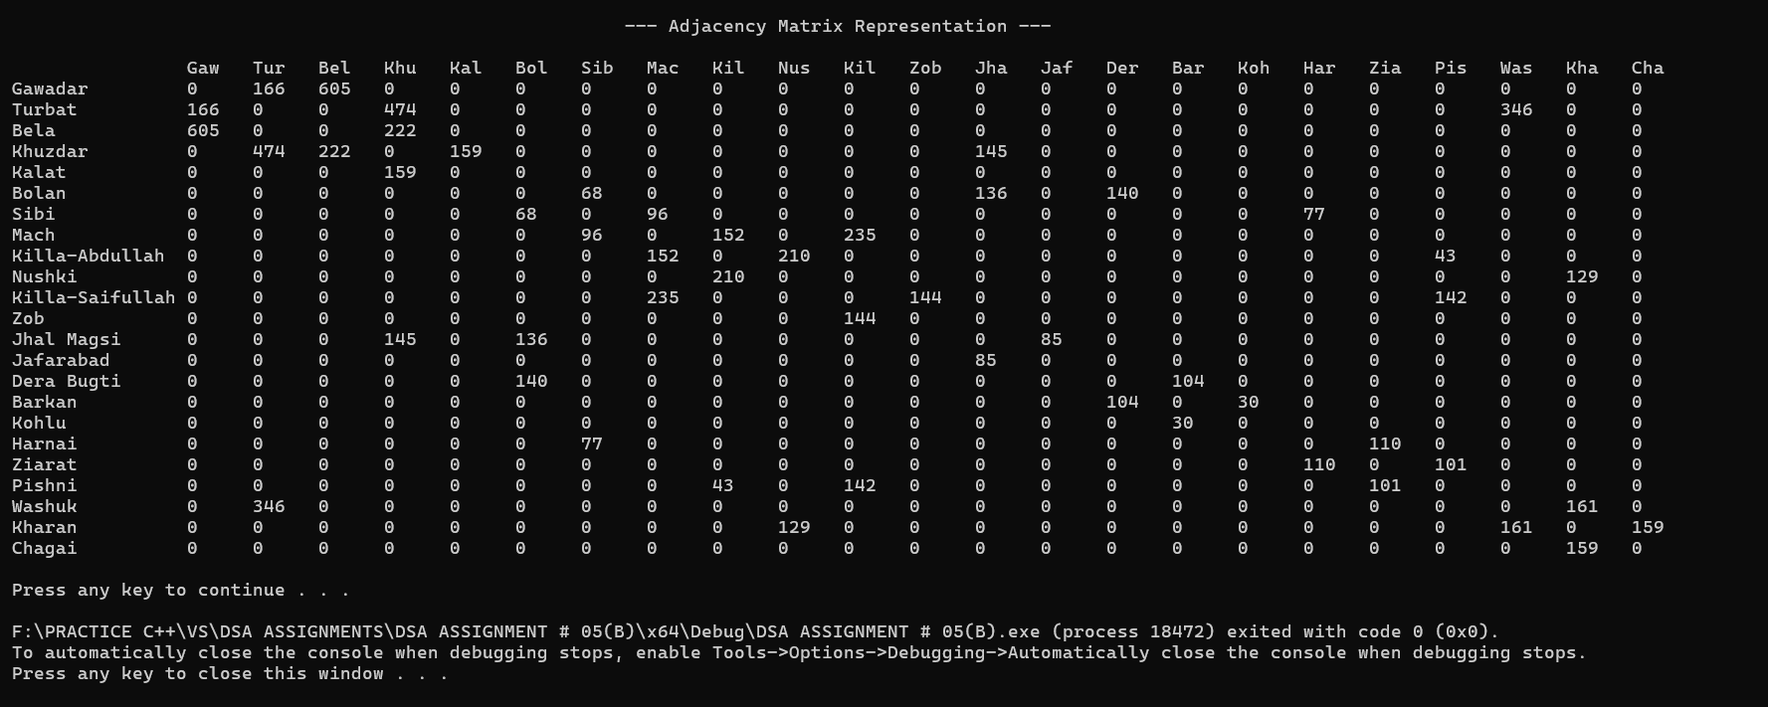
QUESTION#03:
include <iostream> include <string> using namespace std;
// Max cities
const int MAX_SIZE = 50;
// ode Structure struct Cityode
{
int cityId; int weight;
Cityode* nextfltr;
};
// Queue Class (for BFS) class CityQueue
{
private:
int* arr;
int frontflos; int rearflos; int capacity;

public:
CityQueue(int sizeVal = 50); void Enqueue(int val);
int Dequeue(); bool IsEmpty();
};
// Stack Class (for DFS) class CityStack
{
private:
int* arr; int topflos;
int capacity;

public:
CityStack(int sizeVal = 50); void flush(int val);
int flop();
bool IsEmpty();
};
// Graph Class class SearchGraph
{
private:
string names[MAX_SIZE]; int totalCities;
Cityode* adjList[MAX_SIZE];

int GetIndex(string cityame);
void BFSelper(int startId, bool visited[]); void DFSelper(int startId, bool visited[]);

public:
SearchGraph();
void AddCityAndEdge(string u, string v, int dist);

void flerformBFS(string startCity); void flerformDFS(string startCity);
};
// Queue Implementation CityQueue::CityQueue(int sizeVal)
{
capacity = sizeVal;
arr = new int[capacity]; frontflos = 0;
rearflos = -1;
}
void CityQueue::Enqueue(int val)
{
if (rearflos < capacity - 1)
{
arr[++rearflos] = val;
}
}

int CityQueue::Dequeue()
{
if (frontflos > rearflos) return -1;
return arr[frontflos++];
}

bool CityQueue::IsEmpty()
{
return frontflos > rearflos;
}
// Stack Implementation CityStack::CityStack(int sizeVal)
{
capacity = sizeVal;
arr = new int[capacity]; topflos = -1;
}
void CityStack::flush(int val)
{
if (topflos < capacity - 1) arr[++topflos] = val;
}
int CityStack::flop()
{
if (topflos >= 0)
return arr[topflos--]; return -1;
}
bool CityStack::IsEmpty()
{
return topflos == -1;
}
// Graph Implementation SearchGraph::SearchGraph()
{
totalCities = 0;
for (int i = 0; i < MAX_SIZE; i++) adjList[i] = ULL;

}
int SearchGraph::GetIndex(string cityame)
{
for (int i = 0; i < totalCities; i++)
{
if (names[i] == cityame) return i;
}
names[totalCities] = cityame; return totalCities++;
}
void SearchGraph::AddCityAndEdge(string u, string v, int dist)
{
int uIdx = GetIndex(u); int vIdx = GetIndex(v);

// Add v to u
Cityode* node1 = new Cityode; node1->cityId = vIdx;
node1->weight = dist;
node1->nextfltr = adjList[uIdx]; adjList[uIdx] = node1;

// Add u to v (Undirected) Cityode* node2 = new Cityode; node2->cityId = uIdx;
node2->weight = dist;
node2->nextfltr = adjList[vIdx]; adjList[vIdx] = node2;
}
void SearchGraph::BFSelper(int startId, bool visited[])
{
CityQueue q; q.Enqueue(startId); visited[startId] = true;

while (!q.IsEmpty())
{
int curr = q.Dequeue();
cout << names[curr] << " -> ";

Cityode* temp = adjList[curr]; while (temp != ULL)
{
int neighbor = temp->cityId; if (!visited[neighbor])
{
visited[neighbor] = true; q.Enqueue(neighbor);
}
temp = temp->nextfltr;
}
}
}
void SearchGraph::DFSelper(int startId, bool visited[])
{
CityStack s; s.flush(startId);

while (!s.IsEmpty())
{
int curr = s.flop(); if (!visited[curr])
{
cout << names[curr] << " -> "; visited[curr] = true;
}
Cityode* temp = adjList[curr]; while (temp != ULL)
{
int neighbor = temp->cityId; if (!visited[neighbor])
{
s.flush(neighbor);
}
temp = temp->nextfltr;
}
}
}
void SearchGraph::flerformBFS(string startCity)
{
bool visited[MAX_SIZE];
for (int i = 0; i < totalCities; i++) visited[i] = false;
int startIdx = -1;
// Check if user input exists in our map for (int i = 0; i < totalCities; i++) {
if (names[i] == startCity) startIdx = i;
}
if (startIdx == -1) {
cout << "Error!! City not found! Starting from first city from the list." <<

endl;

}

startIdx = 0;

cout << "BFS Traversal Order: "; BFSelper(startIdx, visited);
// andle Disconnected Graph
for (int i = 0; i < totalCities; i++)
{
if (!visited[i]) BFSelper(i, visited);
}
cout << "ED" << endl;
}
void SearchGraph::flerformDFS(string startCity)
{
bool visited[MAX_SIZE];
for (int i = 0; i < totalCities; i++) visited[i] = false;

int startIdx = -1;
for (int i = 0; i < totalCities; i++) {
if (names[i] == startCity) startIdx = i;
}

if (startIdx == -1) { startIdx = 0;

}
cout << "DFS Traversal Order: "; DFSelper(startIdx, visited);
// andle Disconnected Graph
for (int i = 0; i < totalCities; i++)
{
if (!visited[i]) DFSelper(i, visited);
}
cout << "ED" << endl;
}
// Main flrogram int main()
{
SearchGraph balochistan; string userStartCity;

// Loading Table Data (Graph Created in Q2) balochistan.AddCityAndEdge("Gawadar", "Turbat", 166);
balochistan.AddCityAndEdge("Gawadar", "Bela", 605);
balochistan.AddCityAndEdge("Bela", "Khuzdar", 222);
balochistan.AddCityAndEdge("Turbat", "Khuzdar", 474);
balochistan.AddCityAndEdge("Khuzdar", "Kalat", 159);
balochistan.AddCityAndEdge("Bolan", "Sibi", 68);
balochistan.AddCityAndEdge("Sibi", "Mach", 96);
balochistan.AddCityAndEdge("Mach", "Killa-Abdullah", 152); balochistan.AddCityAndEdge("ushki", "Killa-Abdullah", 210); balochistan.AddCityAndEdge("Mach", "Killa-Saifullah", 235);
balochistan.AddCityAndEdge("Killa-Saifullah", "Zob", 144); balochistan.AddCityAndEdge("Khuzdar", "Jhal Magsi", 145); balochistan.AddCityAndEdge("Jhal Magsi", "Jafarabad", 85); balochistan.AddCityAndEdge("Jhal Magsi", "Bolan", 136); balochistan.AddCityAndEdge("Bolan", "Dera Bugti", 140); balochistan.AddCityAndEdge("Dera Bugti", "Barkan", 104); balochistan.AddCityAndEdge("Barkan", "Kohlu", 30); balochistan.AddCityAndEdge("Sibi", "arnai", 77); balochistan.AddCityAndEdge("arnai", "Ziarat", 110); balochistan.AddCityAndEdge("Ziarat", "flishni", 101);
balochistan.AddCityAndEdge("flishni", "Killa-Abdullah", 43);
balochistan.AddCityAndEdge("Turbat", "Washuk", 346);
balochistan.AddCityAndEdge("Washuk", "Kharan", 161); balochistan.AddCityAndEdge("Kharan", "ushki", 129); balochistan.AddCityAndEdge("Kharan", "Chagai", 159);
balochistan.AddCityAndEdge("flishni", "Killa-Saifullah", 142); cout << "--- Graph Traversal (BFS fi DFS) ---" << endl;
cout << "Enter Starting City ame: "; cin >> userStartCity;
cout << endl; balochistan.flerformBFS(userStartCity); cout << endl; balochistan.flerformDFS(userStartCity); cout << endl;
system("pause"); return 0;
}

OUTPUT:
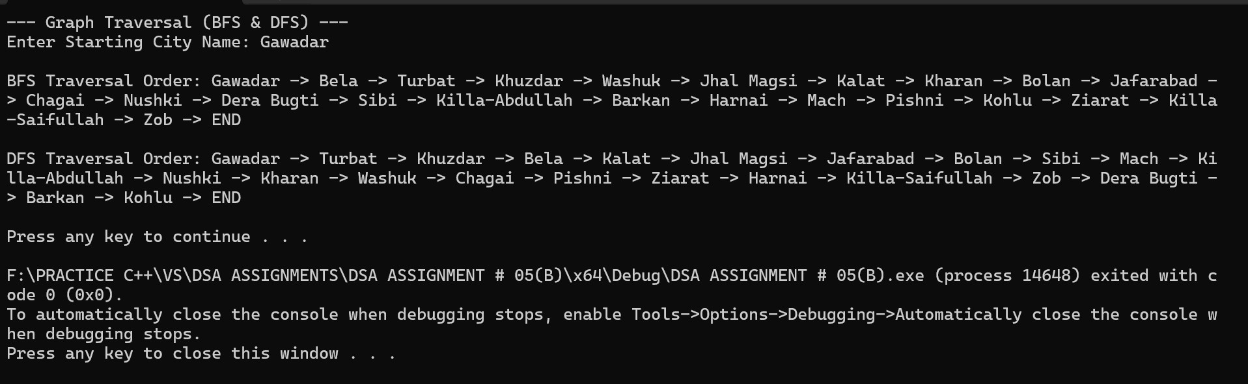

QUESTION#04:
include <iostream> include <string> using namespace std;
// Constants
const int MAX_CITIES = 30;
const int MAX = 1000000; // infinity value
// Graph Class class CityGraph
{
private:
string cityames[MAX_CITIES];
int adjMatrix[MAX_CITIES][MAX_CITIES]; int cityCount;
int getIndex(string name);
int getMinDistanceode(int dist[], bool visited[]); int getMinKeyode(int key[], bool mstSet[]);
void printflath(int parent[], int j);

public:
CityGraph();
void AddCity(string name);
void AddEdge(string u, string v, int w); void RunDijkstra(string startode); void RunflrimMST();
};
// Graph Implementation CityGraph::CityGraph()
{
cityCount = 0;
for (int i = 0; i < MAX_CITIES; i++)
{
for (int j = 0; j < MAX_CITIES; j++)
{
adjMatrix[i][j] = 0;
}
}

}
int CityGraph::getIndex(string name)
{
for (int i = 0; i < cityCount; i++)
{
if (cityames[i] == name) return i;
}
// Auto-add if not found
if (cityCount < MAX_CITIES)
{
cityames[cityCount] = name; return cityCount++;
}
return -1;
}
void CityGraph::AddEdge(string u, string v, int w)
{
int i = getIndex(u); int j = getIndex(v);

if (i != -1 fifi j != -1)
{
adjMatrix[i][j] = w; adjMatrix[j][i] = w; // Undirected
}
}
//To find the node with minimum distance value
int CityGraph::getMinDistanceode(int dist[], bool visited[])
{
int min = MAX, minIndex = -1;

for (int v = 0; v < cityCount; v++)
{
if (!visited[v] fifi dist[v] <= min)
{
min = dist[v]; minIndex = v;
}
}
return minIndex;
}
// Recursive function to print path
void CityGraph::printflath(int parent[], int j)
{
if (parent[j] == -1) return;

printflath(parent, parent[j]); cout << " -> " << cityames[j];
}
// (a) Dijkstra's Algorithm
void CityGraph::RunDijkstra(string startode)
{
int src = getIndex(startode); if (src == -1)
{
cout << "Invalid Source City!" << endl;

return;
}
int dist[MAX_CITIES]; bool visited[MAX_CITIES]; int parent[MAX_CITIES];
for (int i = 0; i < cityCount; i++)
{
dist[i] = MAX; visited[i] = false; parent[i] = -1;
}
dist[src] = 0;
for (int count = 0; count < cityCount - 1; count++)
{
int u = getMinDistanceode(dist, visited); if (u == -1)
break; visited[u] = true;
for (int v = 0; v < cityCount; v++)
{
// Update dist[v] if not visited, edge exists, and path is shorter if (!visited[v] fifi adjMatrix[u][v] fifi dist[u] != MAX fifi
dist[u] + adjMatrix[u][v] < dist[v])
{
dist[v] = dist[u] + adjMatrix[u][v]; parent[v] = u;
}
}
}
// Output Results
cout << endl << "--- Dijkstra's Shortest flaths from " << startode << " ---" << endl;
for (int i = 0; i < cityCount; i++)
{
if (dist[i] == MAX)
{
cout << cityames[i] << ": Unreachable" << endl;
}
else
{
cout << "To " << cityames[i] << " (" << dist[i] << " km): "; cout << startode;
printflath(parent, i); cout << endl;
}
}
}
//for flrim's (Min Key)
int CityGraph::getMinKeyode(int key[], bool mstSet[])
{
int min = MAX, minIndex = -1;

for (int v = 0; v < cityCount; v++)
{
if (!mstSet[v] fifi key[v] < min)
{
min = key[v]; minIndex = v;

}
}
return minIndex;
}
// (b) flrim's Algorithm void CityGraph::RunflrimMST()
{
int parent[MAX_CITIES]; int key[MAX_CITIES]; bool mstSet[MAX_CITIES];

// Initialize
for (int i = 0; i < cityCount; i++)
{
key[i] = MAX; mstSet[i] = false;
}

// Start from first city key[0] = 0;
parent[0] = -1;

for (int count = 0; count < cityCount - 1; count++)
{
int u = getMinKeyode(key, mstSet); if (u == -1)
break; mstSet[u] = true;
for (int v = 0; v < cityCount; v++)
{
if (adjMatrix[u][v] fifi !mstSet[v] fifi adjMatrix[u][v] < key[v])
{
parent[v] = u;
key[v] = adjMatrix[u][v];
}
}
}
// Output Results
cout << endl << "--- flrim's Minimum Spanning Tree ---" << endl; int totalWeight = 0;
for (int i = 1; i < cityCount; i++)
{
if (parent[i] != -1)
{
cout << cityames[parent[i]] << " - " << cityames[i]
<< " \t: " << adjMatrix[i][parent[i]] << " km" << endl; totalWeight += adjMatrix[i][parent[i]];
}
}
cout << "Total MST Distance: " << totalWeight << " km" << endl;
}
// Main flrogram int main()
{
CityGraph balochistan; string startode;
// Load Data (Same as Q2) balochistan.AddEdge("Gawadar", "Turbat", 166);

balochistan.AddEdge("Gawadar", "Bela", 605);
balochistan.AddEdge("Bela", "Khuzdar", 222);
balochistan.AddEdge("Turbat", "Khuzdar", 474);
balochistan.AddEdge("Khuzdar", "Kalat", 159);
balochistan.AddEdge("Bolan", "Sibi", 68);
balochistan.AddEdge("Sibi", "Mach", 96);
balochistan.AddEdge("Mach", "Killa-Abdullah", 152); balochistan.AddEdge("ushki", "Killa-Abdullah", 210); balochistan.AddEdge("Mach", "Killa-Saifullah", 235);
balochistan.AddEdge("Killa-Saifullah", "Zob", 144); balochistan.AddEdge("Khuzdar", "Jhal Magsi", 145); balochistan.AddEdge("Jhal Magsi", "Jafarabad", 85); balochistan.AddEdge("Jhal Magsi", "Bolan", 136); balochistan.AddEdge("Bolan", "Dera Bugti", 140); balochistan.AddEdge("Dera Bugti", "Barkan", 104); balochistan.AddEdge("Barkan", "Kohlu", 30); balochistan.AddEdge("Sibi", "arnai", 77); balochistan.AddEdge("arnai", "Ziarat", 110); balochistan.AddEdge("Ziarat", "flishni", 101);
balochistan.AddEdge("flishni", "Killa-Abdullah", 43);
balochistan.AddEdge("Turbat", "Washuk", 346);
balochistan.AddEdge("Washuk", "Kharan", 161); balochistan.AddEdge("Kharan", "ushki", 129); balochistan.AddEdge("Kharan", "Chagai", 159);
balochistan.AddEdge("flishni", "Killa-Saifullah", 142); cout << "Enter Source City for Dijkstra : ";
cin >> startode; balochistan.RunDijkstra(startode); balochistan.RunflrimMST();
cout << endl; system("pause"); return 0;
}

OUTPUT:
